EARTHQUAKE / WILDFIRE “GO KIT” PREPARATION
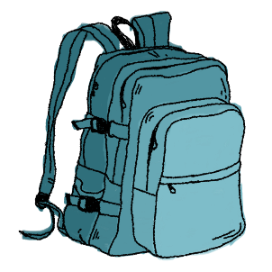
Every family member should have their own pre-assembled “custom” Emergency Go Kit. Light weight waterproof back packs are recommended.

Why is this important? A major earthquake could likely cause heavy outside and interior damage You MUST leave your house when the shaking stops and it is safe to exit. Trying to frantically grab last minute items inside your house could cost you serious injury or your life. A wildfire can consume your home in minutes without local adequate official warning. Wildfires pose a serious threat with extreme heat and toxic smoke. Both are killer! There is no time to collect your possessions. Build your GO KIT!

“Failuring to plan is planning to fail.” Start preparing with these basic essentials:

- WATER (Four 12 ounce bottles equals ½ gallon. You require 1 gal. per day)
- PROTEIN MIX PACKETS (Low sodium or no salt at all.)
- LED FLASHLITE (Extra batteries)
- PHOTO ID (Include card with blood type, physical limitations, allergies, etc. Attach to the exterior of your back pack for immediate EMT recognition)
- CELL PHONE with CHARGER (Download emergency numbers incl. local PD/fire, out-of-area family, County & Tri-Valley alert agencies.)
- FIRST AID SUPPLIES (Bandages, adhesive tape, flex tape, non-stick pads, Neosporin, eye wash, alcohol, latex plastic gloves, scissors. Aspirin, Tylenol)
- PRESCRIPTION MEDICINES
- NP 95 FACE MASKS (Minimum 3 masks per individual.)
- SANITATION SUPPLIES (tissues, tooth paste/brush, comb, liquid soaps, paper towels, toilet paper, zip lock plastic bags)
- CASH (Small bills - $20, $10, $5, $1.)
- NOTEPAD & PEN
- PROTECTIVE RAIN PANCO (winter months recommended)
- Plan a GO KIT for your PET also!

